F Y B Tech SEM I 2021-22

Engineering Physics Lab Course

**Experiment No.: 2**

**Title: Photoelectric Effect**

**Name: Hardik Shah**

**Roll No: 16010221025**

**Branch: ETRX**

**Batch: D2**

**Aim:** To verify the relation between thermo emf of a thermocouple and temperature difference between two hot junctions.

**Apparatus:** A hot body, a cold body, a platinum wire, a rhodium wire and a voltmeter.

**Diagram:**

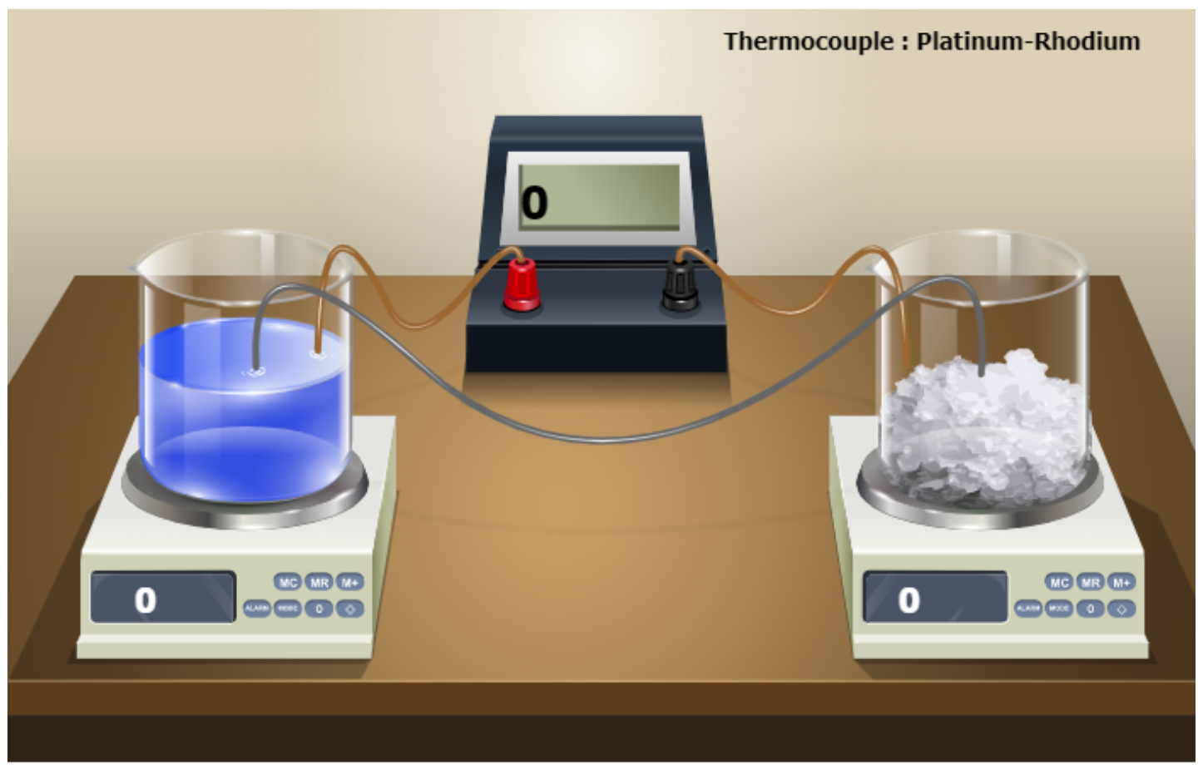

**Observation Table:**

|  |  |  |  |
| --- | --- | --- | --- |
| **Sr. No.** | **Hot Temperature** | **Cold Temperature** | **Hot emf** |
| **1.** | **500** | **0** | **4.471** |
| **2.** | **700** | **0** | **6.743** |
| **3.** | **900** | **0** | **9.205** |
| **4.** | **1100** | **0** | **11.850** |
| **5.** | **1300** | **0** | **14.629** |

**Graphs*:**

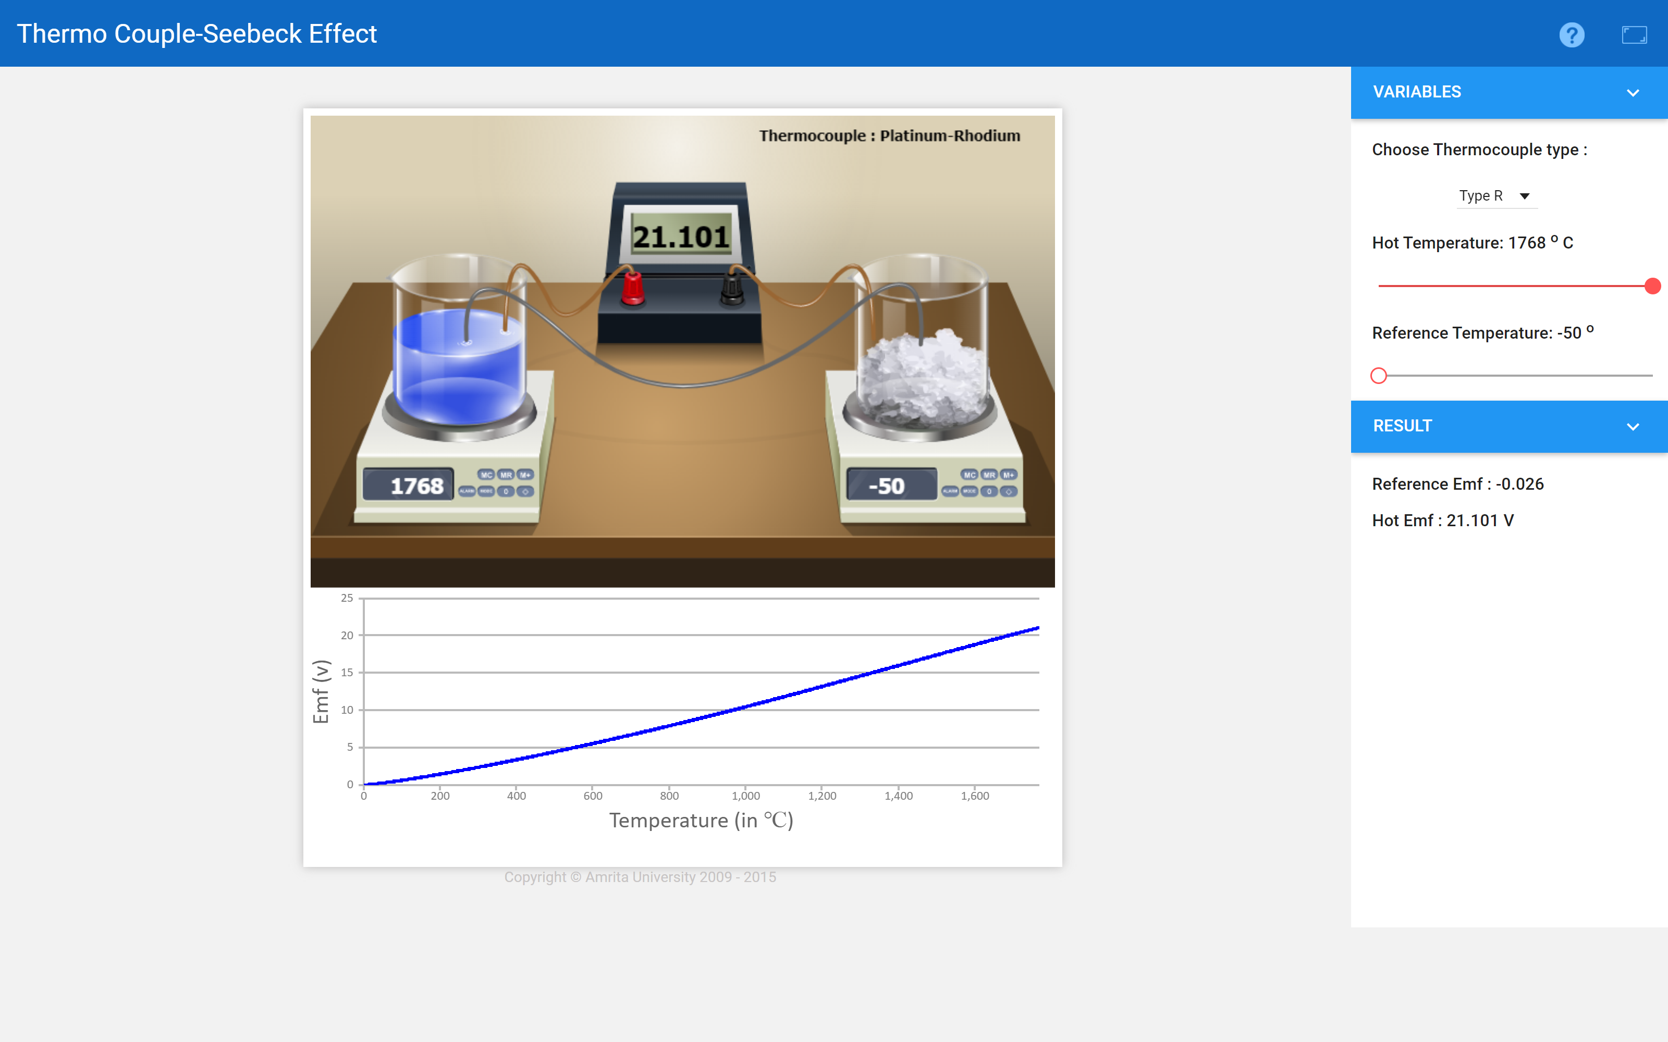

**Results:**

**Link for home assignment uploaded:**